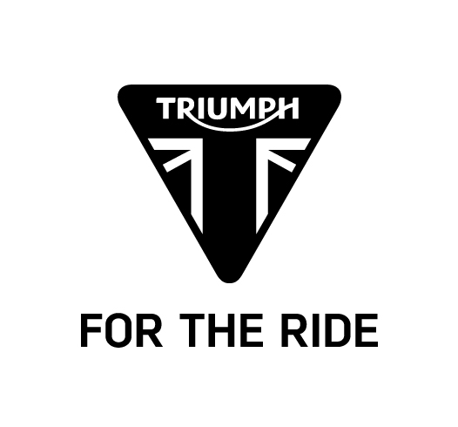

Thruxton and Thruxton R
SPECIFICATION

Engine and transmission
 | THRUXTON | THRUXTON R
Type | Liquid cooled, 8 valve, SOHC,  270° crank angle parallel twin | Liquid cooled, 8 valve, SOHC,  270° crank angle parallel twin
Capacity | 1200cc | 1200cc
Bore/Stroke | 97.6 x 80 mm | 97.6 x 80 mm
Compression Ratio | 11.0:1 | 11.0:1
Maximum Power | 97 PS/ 96 hp (72 kW) @ 6750 rpm | 97 PS/ 96 hp (72 kW) @ 6750 rpm
Maximum Torque | 112 Nm @ 4950 rpm | 112 Nm @ 4950 rpm
Fuel system | Multipoint sequential electronic fuel injection | Multipoint sequential electronic fuel injection
Exhaust | Chromed 2 into 2 exhaust system  with twin chrome silencers | Brushed stainless steel 2 into 2 exhaust system with twin silencers
Final drive | X ring chain | X ring chain
Clutch | Wet, multi-plate assist clutch | Wet, multi-plate assist clutch
Gearbox | 6-speed | 6-speed

Fuel consumption and emissions
 | THRUXTON & THRUXTON R
Standard | EURO 4
Fuel Consumption | 4.6 l/100km (61 MPG)
Emissions | CO₂ - 106.0 g/km

CO₂ and fuel consumption are measured according to regulation 168/2013/EC. Figures on fuel consumption are derived from specific test conditions and are for comparative purposes only. They may not reflect real driving results.

Chassis
 | THRUXTON | THRUXTON R
Frame | Tubular steel cradle | Tubular steel cradle
Swingarm | Twin-sided, aluminium | Twin-sided, aluminium - Clear anodized
Front Wheel | 32-spoke 17 x 3.5in | 32-spoke 17 x 3.5in
Rear Wheel | 32-spoke 17 x 5in | 32-spoke 17 x 5in
Front Tyre | 120/70 ZR 17 - Pirelli Angel GT | 120/70 ZR 17 - Pirelli Diablo Rosso Corsa
Rear Tyre | 160/60 ZR17 - Pirelli Angel GT | 160/60 ZR17 - Pirelli Diablo Rosso Corsa
Front Suspension | Kayaba 41mm cartridge forks, 120mm travel | Showa 43mm USD big piston forks, fully adjustable 120mm travel
Rear Suspension | Kayaba twin shocks with adjustable preload, 120mm rear wheel travel | Fully adjustable Ohlins twin shocks with piggy back reservoir , 120mm rear wheel travel
Front Brake | Twin 310mm discs, Nissin 2-piston axial  floating calipers, ABS | Brembo twin 310mm floating discs  Brembo 4-piston radial monobloc calipers, ABS
Rear Brake | Single 220mm disc, Nissin 2-piston axial floating caliper, ABS | Single 220mm disc, Nissin 2-piston axial  floating caliper, ABS

Dimensions and weight
 | THRUXTON | THRUXTON R
Length | 2105 mm | 2105 mm
Width (Handlebars) | 745 mm | 745 mm
Height Without Mirrors | 1030 mm | 1030 mm
Seat Height | 805 mm | 810 mm
Wheelbase | 1415 mm | 1415 mm
Rake | 22.7º | 22.8º
Trail | 90.8 mm | 92 mm
Dry Weight | 206 Kg | 203 kg
Fuel Tank Capacity | 14.5 L | 14.5 L

Standard equipment
 | THRUXTON | THRUXTON R
Standard  Equipment | Switchable ABS  Switchable Traction Control  Ride-by-Wire  Riding Modes  LED DRL headlight  Monza cap  USB socket  Immobiliser  LED rear light | Switchable ABS  Switchable Traction Control  Ride-by-Wire  Riding Modes  LED DRL headlight  Monza cap  USB socket  Immobiliser  LED rear light  Tank strap

