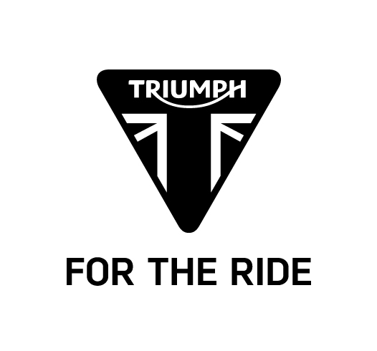

Bonneville T120 & Bonneville T120 Black
SPECIFICATION

Engine and transmission
 | BONNEVILLE T120 | BONNEVILLE T120 BLACK
Type | Liquid cooled, 8 valve, SOHC, 270° crank angle parallel twin | Liquid cooled, 8 valve, SOHC, 270° crank angle parallel twin
Capacity | 1200cc | 1200cc
Bore/Stroke | 97.6mm x 80mm | 97.6mm x 80mm
Compression Ratio | 10.0:1 | 10.0:1
Maximum Power | 80 PS/ 79 Bhp (59 kW) @ 6550 rpm | 80 PS/ 79 Bhp (59 kW) @ 6550 rpm
Maximum Torque | 105 Nm @ 3100 rpm | 105 Nm @ 3100 rpm
Fuel system | Multipoint sequential electronic fuel injection | Multipoint sequential electronic fuel injection
Exhaust | Chromed 2 into 2 exhaust system with twin chrome silencers | Black 2 into 2 exhaust system with twin black silencers
Final drive | X ring chain | X ring chain
Clutch | Wet, multi-plate assist clutch | Wet, multi-plate assist clutch
Gearbox | 6-speed | 6-speed

Fuel consumption and emissions
Standard | EURO 4
Fuel Consumption | 4.5 l/100km (63 MPG)
Emissions | CO₂ - 103.0 g/km

CO₂ and fuel consumption are measured according to regulation 168/2013/EC. Figures on fuel consumption are derived from specific test conditions and are for comparative purposes only. They may not reflect real driving results.
Chassis
 | BONNEVILLE T120 | BONNEVILLE T120 BLACK
Frame | Tubular steel cradle | Tubular steel cradle
Swingarm | Twin-sided, tubular steel | Twin-sided, tubular steel
Front Wheel | 32-spoke 18 x 2.75in | 32-spoke 18 x 2.75in
Rear Wheel | 32-spoke 17 x 4.25in | 32-spoke 17 x 4.25in
Front Tyre | 100/90-18 | 100/90-18
Rear Tyre | 150/70 R17 | 150/70 R17
Front Suspension | Kayaba 41mm cartridge forks, 120mm travel | Kayaba 41mm cartridge forks, 120mm travel
Rear Suspension | Kayaba twin shocks with adjustable preload, 120mm rear wheel travel | Kayaba twin shocks with adjustable preload, 120mm rear wheel travel
Front Brake | Twin 310mm discs, Nissin 2-piston floating calipers, ABS | Twin 310mm discs, Nissin 2-piston floating calipers, ABS
Rear Brake | Single 255mm disc, Nissin 2-piston floating  caliper, ABS | Single 255mm disc, Nissin 2-piston floating  caliper, ABS

Dimensions and weight
 | BONNEVILLE T120 | BONNEVILLE T120 BLACK
Length | 2170 mm | 2170 mm
Width (Handlebars) | 785 mm | 785 mm
Height (Without Mirrors) | 1125 mm | 1125 mm
Seat Height | 785 mm | 785 mm
Wheelbase | 1445 mm | 1445 mm
Rake | 25.5º | 25.5º
Trail | 105.2 mm | 105.2 mm
Dry Weight | 224 Kg | 224 Kg
Fuel Tank Capacity | 14.5 L | 14.5 L

Standard equipment
ABS
Traction Control
Ride-by-Wire
Riding Modes
LED DRL headlight
Heated grips
Centre stand
Passenger grab rail
Immobiliser
LED rear light

